PRESS RELEASE
COMMUNICATIONS AND MEDIA TEAM OF THE 43RD ASEAN SUMMIT 2023
No. 114/SP/TKM-ASEAN2023/ENG/9/2023

Indonesia Identifies Cooperation Projects Worth Rp490.59 Trillion through AIPF
JAKARTA, 7 September 2023 – Indonesia identified cooperation projects worth US$32 billion or around Rp490.59 trillion through business matching activities conducted during the ASEAN-Indo-Pacific Forum (AIPF).
As host of the AIPF, which was a flagship event of the 43rd ASEAN Summit, Indonesia also pursued cooperation for projects from other countries with a total value of US$810 million (approximately Rp12.4 trillion).
“Although it could not be finalized in today's meeting, we hope that the business matching will be able to improve cooperation and understanding of the actual investment needs expected by each country,” said Deputy Minister of Foreign Affairs Pahala Mansury when delivering a press statement regarding the AIPF in Jakarta, Wednesday (6 September 2023).
Around 185 domestic and international investors attended the business matching activity of AIPF, including PT Bank Mandiri Tbk, Bank Permata, Bank SBI Indonesia, Bank CCB Indonesia, PT Bank Jawa Barat, PT Astra Infrastruktur, PT Amman Mineral Tbk, Dian Swastatika Sentosa, AIIB, Standard Chartered, Sumitomo (SMBC), Commerzbank, ACWA (Saudi Arabia), EDF Energy (France), KEPCO (Korea Republic), IGNIS (Spain), China Railway Corporation, Sinohydro, China State Construction Engineering, Siemens (Germany), Inpex Geothermal (Japan), British Columbia (Canada), and Actis (United Kingdom).
Business sectors promoted through the AIPF include the development of renewable energy, hydrogen, ammonia, alumina refinery, battery supply chains, as well as toll road and port infrastructure.
Indonesia focused on international partnerships for strategic projects in the fields of energy and oil and gas (five projects), toll roads (nine projects), ports (five projects), healthcare (six projects), fertilizers (three projects), infrastructures (ten projects), tourism (nine projects), as well as the electric vehicle battery ecosystem and supply chain (three projects).
According to Deputy Minister of State-Owned Enterprises (SOEs) Rosan Roeslani, the sectors that attracted the most interest from investors were green energy and the electric vehicle battery ecosystem.
“Many of them were interested in participating in the digitalization sector because they saw a lot of potential in our population that has not been touched yet by formal financing,” said Rosan.
He mentioned that several of Indonesia’s largest SOEs such as Pertamina, Pupuk Indonesia, PLN, Pelindo, Jasa Marga, MIND ID, and Injourney, also participated in AIPF.
The Agency of National Development Planning (Bappenas) also showcased several strategic projects, which were expected to serve as investment acceleration platforms for various infrastructure projects such as the Demak-Tuban, Tuban-Gresik, Tasikmalaya-Gedebage-Ciamis toll road projects, and the Jatiluhur Drinking Water Supply System (SPAM) project. In addition, several ASEAN countries such as Brunei, Myanmar, Thailand, Malaysia, and the Philippines also presented potential projects in the telecommunications and infrastructure sectors.
Leaders from ASEAN countries such as President Ferdinand Marcos Jr. of the Philippines, Prime Minister Lee Hsien Loong of Singapore, the Head of Delegation of the Kingdom of Thailand Sarun Charoensuwan, Prime Minister Pham Minh Chinh of Vietnam, Prime Minister Sonexay Siphandone of Laos, Sultan Hassanal Bolkiah of Brunei Darussalam, Prime Minister Hun Manet of Cambodia, Prime Minister Dato’ Seri Anwar Ibrahim of Malaysia, and Prime Minister Xanana Gusmao of Timor-Leste also attended the AIPF that was held from 5 – 6 September 2023.
Three world leaders, including Prime Minister Fumio Kishida of Japan, Prime Minister Anthony Albanese of Australia, and Prime Minister Justin Trudeau of Canada, were also present and served as key speakers during the leaders' talk session.
Pahala explained that these three leaders emphasized that future priorities for strategic partnerships with ASEAN will be focused on sustainable cooperation sectors such as clean energy development, innovative and sustainable financing, and green infrastructure development. (WW)
***
For more information, please contact:
Director for Information and Media Services of the Ministry of Foreign Affairs – Hartyo Harkomoyo (0811831899)
Get more information at http://asean2023.id, https://infopublik.id/kategori/asean-2023, and https://indonesia.go.id/kategori/ragam-asean-2023
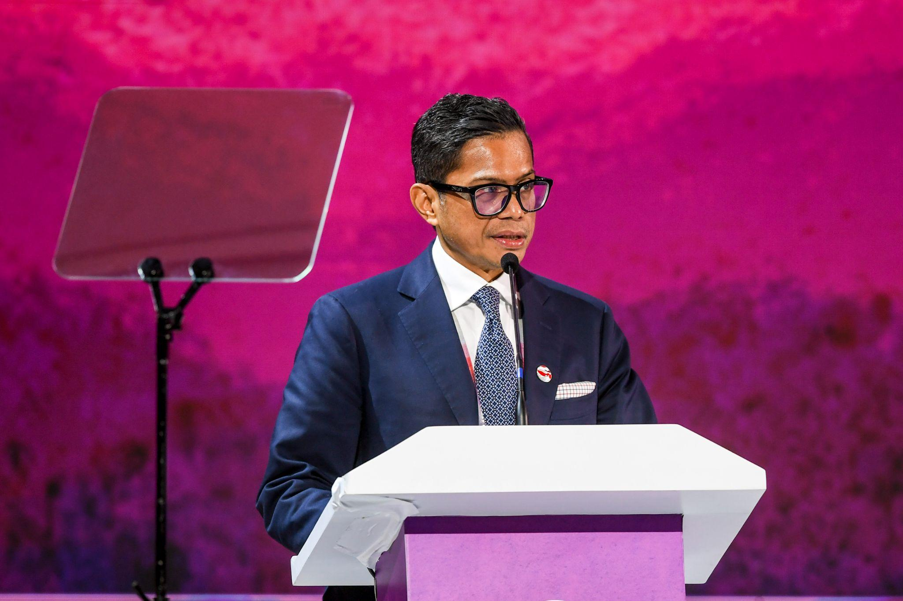

Deputy Minister of Foreign Affairs Pahala Nugraha Mansury delivered a presentation with the theme “Indonesia's Plan to Develop Green Infrastructure” on the second day of the ASEAN-Indo-Pacific Forum (AIPF) at Hotel Mulia, Jakarta, on Wednesday, (6 September 2023). Photo: Media Center KTT ASEAN 2023/Galih Pradipta/aww.

